**Satplot User Guide**

Version 2.3

September 2, 2024

[**Jeffrey.R.Hall@jpl.nasa.gov**](mailto:Jeffrey.R.Hall@jpl.nasa.gov)

[**Paulett.Liewer@jpl.nasa.gov**](mailto:Paulett.Liewer@jpl.nasa.gov)

[**Christian.Moestl@uni-graz.at**](mailto:Christian.Moestl@uni-graz.at) (curve fitting procedures)

[**Paulo.Penteado@jpl.nasa.gov**](mailto:Paulo.Penteado@jpl.nasa.gov)

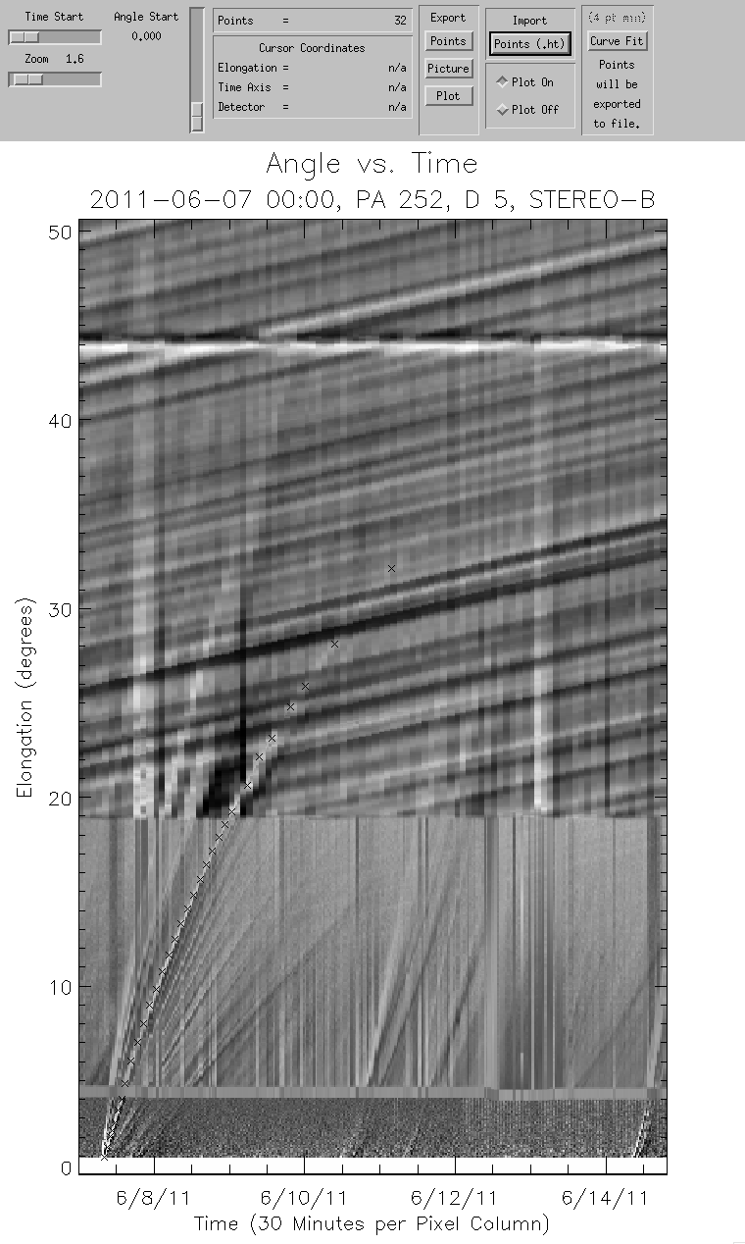***Figure 1.***

**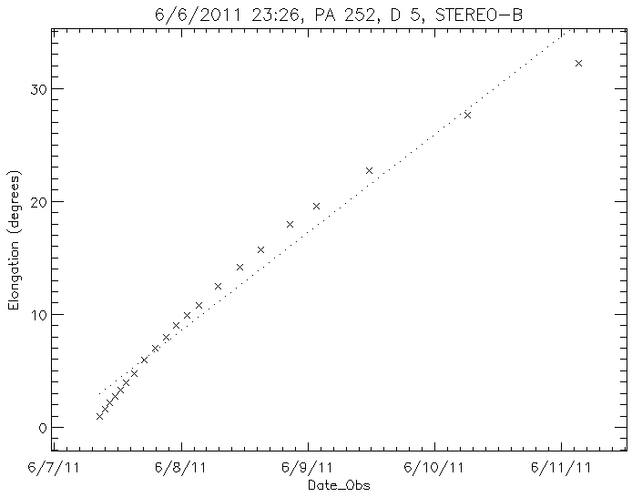 *Figure 2*.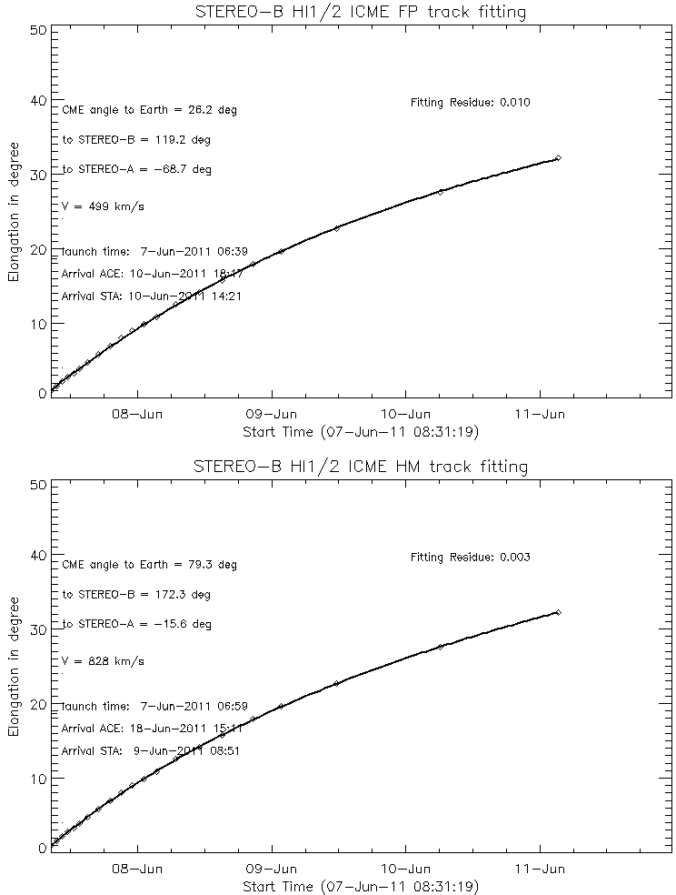 *Figure 3.***

**CONTENTS**

**Introduction**

**Operational Overview**

**Operational Detail**

**Troubleshooting**

**References**

**Introduction**

A tool for Analysis of SECCHI Heliospheric Imager Data.

Available in SolarSoft under the ‘secchi’ instrument tree.

SATPLOT is a software tool for tracking solar wind structures (CME, CIRs, etc.) through the heliosphere using SECCHI Coronagraph and Heliospheric Imager data. It must be run in the IDL SolarSoft environment. It uses “jplots” – plots of elongation (angle from the Sun) versus time at a fixed position angle spanning an angular width (delta). The purpose of SATPLOT is to interactively acquire and plot a curve of elongation vs. time values for solar wind feature seen in the jplots and also save the values to a text file for further analysis (Figures 1 & 2). Routines for creating the jplots are part of the software package. The software package also includes two methods of curve fitting to perform the conversion from elongation vs. time to an actual 3D trajectory (propagation angle and distance from the Sun).

This tool relies on pre-processing performed at JPL with resulting intermediate products made available over the internet which are needed to create the jplots. Two computationally intensive steps are performed in this backend processing. First, running difference images are created from COR2, HI_1 and HI_2. Second, the difference images from the three telescopes are reprojected into modified composite cylindrical (Plate Carree) maps (Figure 4). Such maps have been created at 30 minute intervals for the entire STEREO mission for both the A and B spacecraft. They are “modified” in that latitude (radius) is stretched 4x to accentuate detail in the radial direction. These maps are kept up-to-date and usually lag from real time by three to several days. These maps are the intermediate product that must be downloaded in order to construct a jplot. Downloading cylindrical maps for a time span of interest allows the user to rapidly interact with the data to obtain elongation vs. time plots.

The maps are a helioprojective radial coordinate system (see reference, Thompson). PA is measured counter-clockwise from solar north. The spacecraft orbit plane moves up and down by 7.5degs. From the referenced paper by Thompson: “In essence, helioprojective coordinates are celestial spherical coordinates that use the Sun to define their pole and origin, and which can be extended from disk center out into the corona, and ultimately over the full 4 π steradian sky.” In other words, solar north is constant but the images mapped into the cylindrical maps will wander back and forth by 7.5 degrees as the spacecraft orbits the Sun.

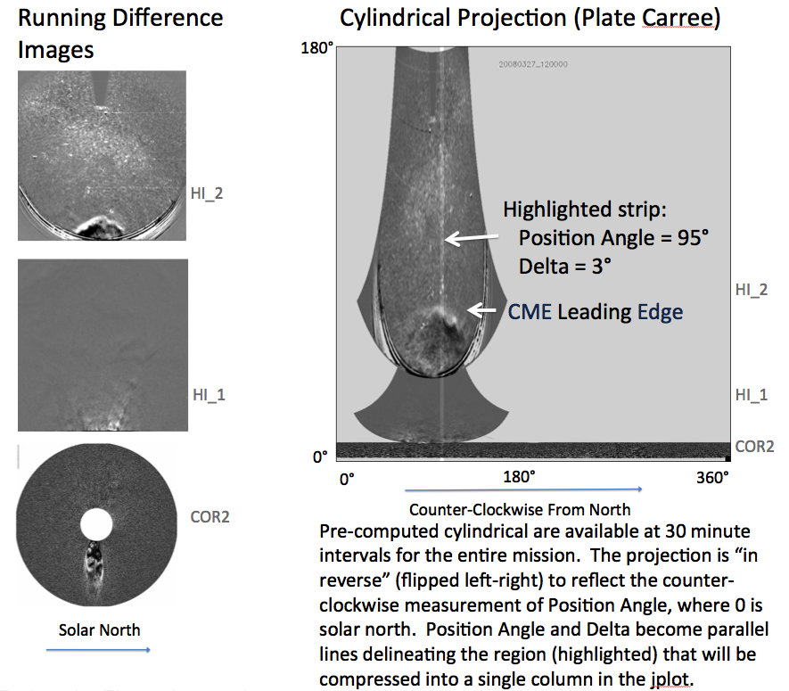

***Figure 4.*** *Left – difference images of the three telescopes. Right – Plate Carree cylindrical map reprojection.*

**Operational Overview**

Step 1: Download the pre-computed cylindrical maps (called pcmaps for Plate Caree) for the time span of interest.

Step 2: Select the Position Angle and Delta using jpredict and jpredict_movie.

Step 3: Generate jplot using jplot.pro.

Step 4: Select points tracking the feature of interest on the jplot tracing using satplot.pro; a scattergram plot is automatically produced.

Step 5: Curve fit.

Step 6: Save points to text file for analysis.

Step 7: Clean up.

**Operational Detail**

**Step 1**

Download the cylindrical maps for time span of interest (Figure 5) from the website at APL https://solar.jhuapl.edu/Data-Products/COR2-HI.php (or /jmap_b for STEREO-B). Usually you will want several whole days’ worth of data to bracket the CME event. There are 48 maps per day per spacecraft at 30 minute cadence, for a total of 96 maps per day for STEREO A+B. Each map is about 200 KB. You may wish to create a new working directory just for this purpose.

In the example below, a CME in March 2008 is tracked.

Example URL:

<https://solar.jhuapl.edu/secchi/jpl/jmap_a/jmap/20090327/>

Script to obtain the pcmaps for March 24-29, 2008. Tested on Linux.

example_download.csh

#!/bin/csh

# $Id:

# Example script for downloading daily series (30 minute cadence) jmap sets (a.k.a. pcmap) from JPL.

# Change dates (yyyymmdd) as needed.

foreach date (20080324 20080325 20080326 20080327 20080328 20080329)

foreach img (`curl -sl https://solar.jhuapl.edu/secchi/jpl/jmap_a/jmap/$date/ | grep _a_jmap.png | cut -d ' ' -f 5 | cut -c 7-32`)

echo transferring: $img

curl -s -O https://solar.jhuapl.edu/secchi/jpl/jmap_a/jmap/$date/$img

end

foreach img (`curl -sl https://solar.jhuapl.edu/secchi/jpl/jmap_b/jmap/$date/ | grep _b_jmap.png | cut -d ' ' -f 5 | cut -c 7-32`)

echo transferring: $img

curl -s -O https://solar.jhuapl.edu/secchi/jpl/jmap_b/jmap/$date/$img

end

end

This example will copy all maps for STEREO-A and -B for six full days. It will transfer 576 cylindrical maps to your local directory and consume about 120 MB.

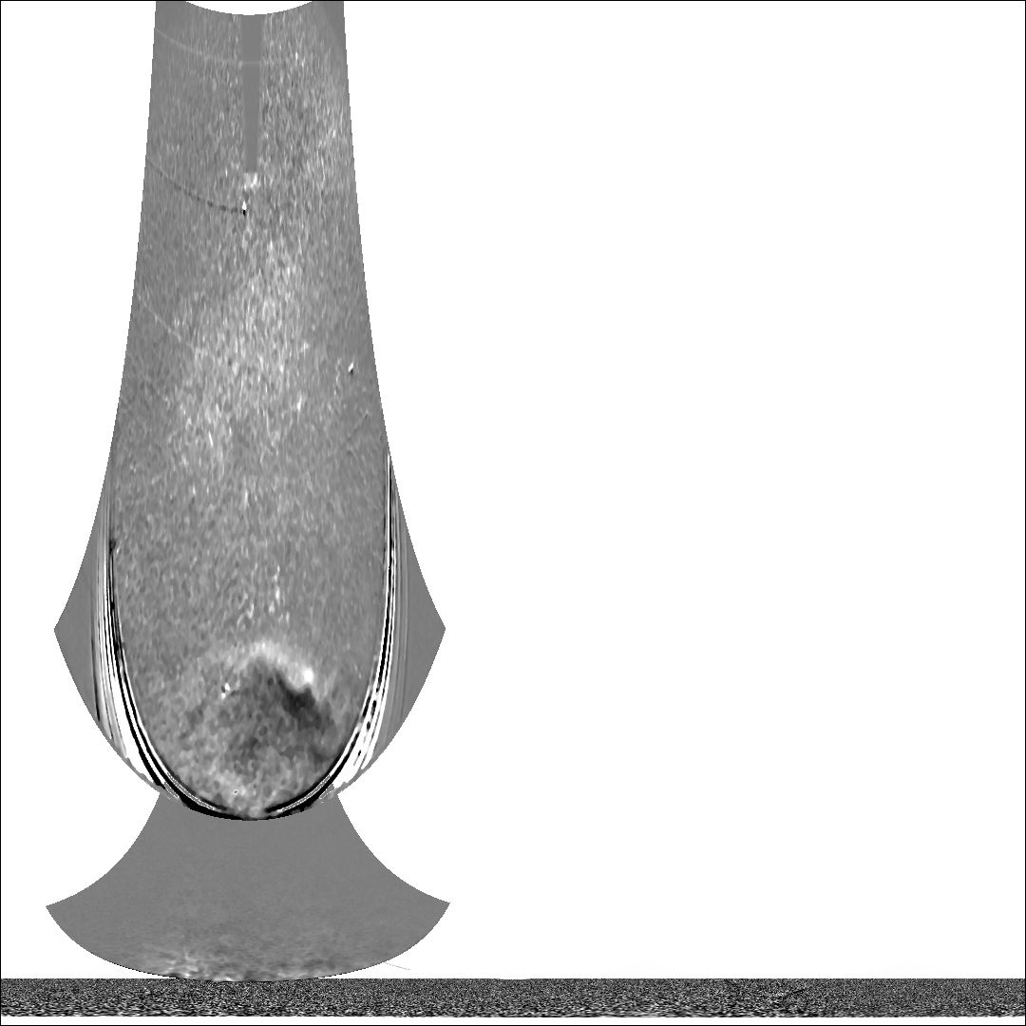 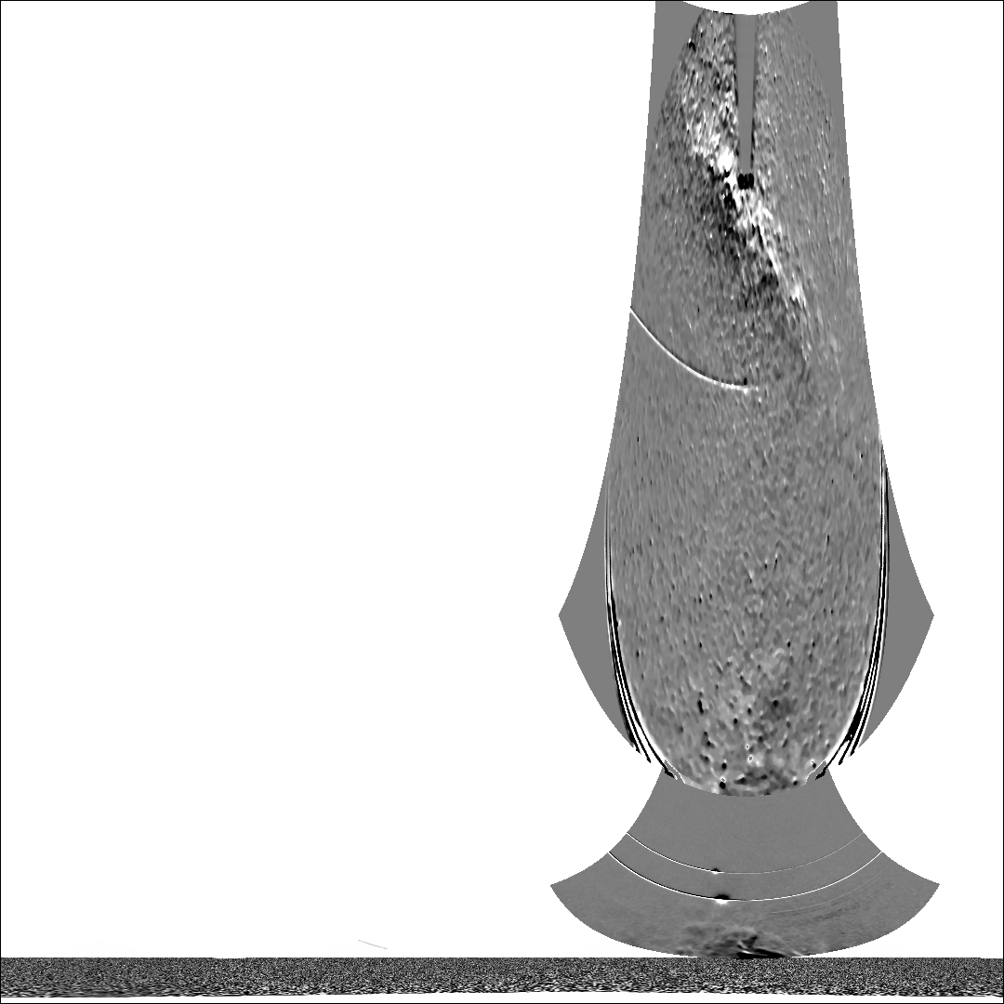

***Figure 5.*** *STEREO-A and -B modified cylindrical maps (20080327_120000).*

Confusingly, the pcmaps (modified cylindrical maps) are named “*_jmap.png” so watch out for that detail.

**Step 2**

Select values for Position Angle and Delta, the width of the strip in position angle. Use jpredict and/or jpredict_movie to help select and/or verify Position Angle and Delta. Position Angle for STEREO-A will usually be 90 (± 60) degrees and 270 (± 60) for STEREO-B. Delta values between 3 and 10 seem to work well. Your choices will need to conform to your needs. These values depend greatly on the specific CME, or portion of the CME event that is of interest.

jpredict (Figure 6) and jpredict_movie are provided to assist in quickly determining what values should result in the best jplot representation. These tools illustrate the data strip that will be compressed into one column (per map) in the jplot. They are intended to be run iteratively as the user tests various values. It may be preferable to use only jpredict_movie if your computer system is fast enough. Because CME’s have irregular shapes that change through time, the selection of these values is critical to having a specific portion of the CME captured in the jplot. The user should allow adequate time for this interactive step.

Examples:

IDL> jpredict, '20080327_000000', 95, 3, 'a', /local

IDL> jpredict_movie, '20080324_000000', '20080330_000000', 95, 3, 'a', /local

The keyword /local is required when using pcmaps that are located in your current working directory.

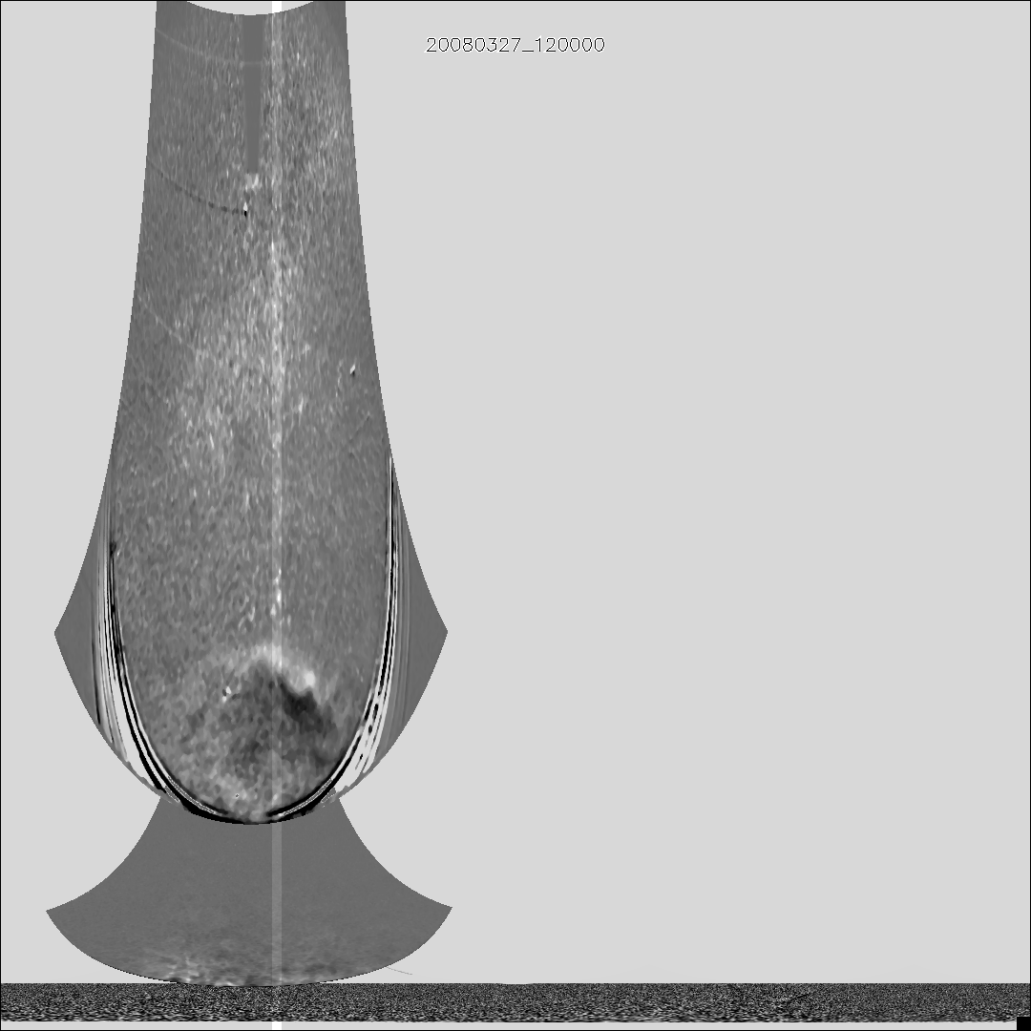

***Figure 6.*** *Picture of jpredict showing selected Position Angle of width Delta. A figure for jpredict_movie would look the same but would be a time-lapse movie version.*

The individual frames of the jpredict_movie can be saved for use later using the “save” keyword as shown in this example:

IDL> jpredict_movie, '20080324_000000', '20080330_000000', 95, 3, 'a', /local,/save

**Step 3**

Generate raw jplot image (Figure 7). The jplot is composed of columns, where each column is one time step, or thirty minutes. Image data is extracted from the cylindrical maps (according to Position Angle and delta) and its width is compressed (averaged) into a single column. In this manner the jplot is built up in thirty-minute time steps from the start time to the end time. The resulting jplot is saved as a PNG image file to be used as input to SATPLOT.

Example:

IDL> jplot, '20080324_000000', '20080330_000000', 95, 3, 'a', /local

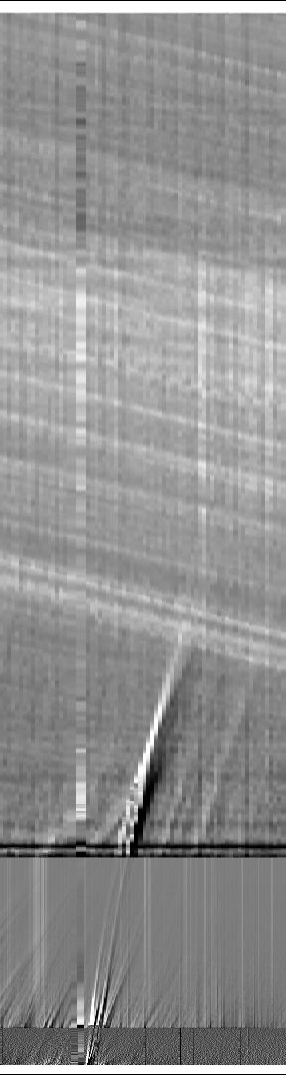

***Figure 7.*** *Raw jplot image.*

At the end of jplot execution the next command (satplot is detailed in step 4) will be printed to the terminal and may be immediately executed by copy-and-paste.

Decoding the jplot: Features in the jplot that curve upward are approaching the observer. Features in the jplot that curve to the right are moving away from the observer.

**Step 4**

Use SATPLOT to select points on the jplot describing the CME trajectory though time (Figure 8, left).

SATPLOT presents the raw jplot in an interactive interface that has labeled axes, and controls for pan and zoom. Points can be added and deleted with left and right clicks, respectively. The program automatically sorts the points in ascending order in time. Points may be added or deleted in any order.

Trajectory definition in SATPLOT is aided by cursor readouts, zoom, pan, point scattergram and the save function, explained below.

Cursor readouts reflect the mouse position with regard to the axis values. The cursor readout also reports the name of the camera, which is determined by angle threshold values and is not always correct near a boundary.

Note: Cursor readouts in the software version at JPL reflect a reverse-lookup where the cursor position is traced back to the difference images to accurately reflect the TIME-OBS of the pixel in the jplot. That implementation is more accurate than the x-axis value because pixels along a jplot column vary in time due to there being three cameras per column. For the software version distributed through SolarSoft this feature had to be simplified because of the lack of access to the difference images. Potentially this reverse-lookup capability could be re-introduced if an alternate implementation solution was developed.

Zoom is controlled via the Zoom slider. Zooming is anchored at the pixel that is currently located in the lower left corner of the image plot, which depends on the current zoom and pan positions. Zoom will be most useful when selecting points at smaller elongation values.

Panning in the x-axis is controlled via the Time Start slider. This is greyed out when data does not extend beyond the end of the x-axis. The zoom control can stretch the data beyond that point at which time the Time Start slider will become active. Resizing the window can also affect the length of the x-axis.

Panning in the y-axis is controlled via the Angle Start slider. Axes are redrawn during zooming and panning to display the new positions. The y-axis can also become greyed out, but this usually does not occur because most computer displays are not tall enough to accommodate the entire height of the jplot. The vertical Angle Start slider is necessary to access the upper regions of the jplot.

The point scattergram (Figure 2 and Figure 8, right) reflects points selected by the user. This scattergram updates every time a point is added or deleted. A least squares fit line is drawn though the point distribution. The scattergram can be turned off and back on again.

There are three Save buttons: Picture saves the SATPLOT with axes, “Plot” saves a picture of the point scattergram and Report writes the points to a “height-time” text file.

Example:

IDL> satplot, 'jplot_20080324_000000__20080330_000000__95__3__A.png'

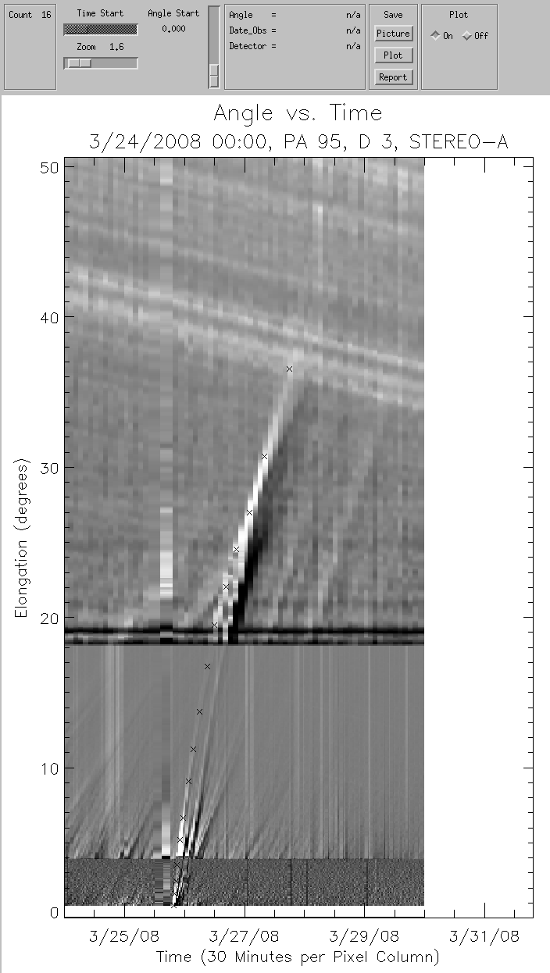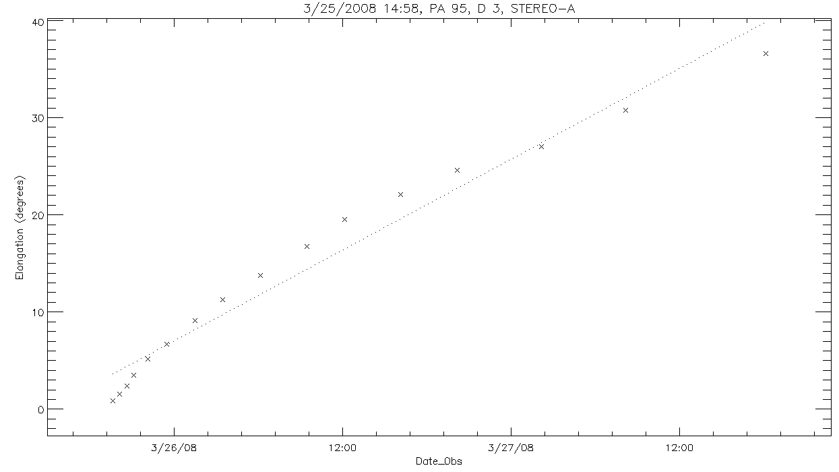

***Figure 8.*** *SATPLOT interface (left) and point scattergram (right).*

Initial length of the SATPLOT elongation axis depends on screen size. The SATPLOT interface window is resizable.

The scattergram window is also resizable, but the scattergram will only update when triggered by adding or deleting a point. To force an update, a point may be added and immediately deleted with a left-click followed by a right-click before moving the mouse. Turning the scattergram off and back on again will force it to return to it’s original size.

Occasionally the scattergram plot will fail to Export (save) correctly. Check your saved plot image to make sure that it is correct. If not then again click on the Export -> Plot button and then it should save correctly.

**Step 5**

Curve fitting: The Curve Fit button will become available after a minimum of 4 points have been selected. The Curve Fit button invokes software written by Christian Moestl to fit two different models to derive the CME speed, direction and arrival time from the elongation vs. time data. Both the speed and the direction are assumed to be constant. The two models ate the “Fixed Phi” and “Harmonic Mean” (Figure 3). Refer to the References section at the end of this document for more about the curve fit and the different methods.

The curve fit will be displayed in the plot window. The plot window has different aspect ratios for the scattergram plot vs the curve fit plot. When the Curve Fit button is invoked, the plot window will show the curve fit. There are two ways to return to the scattergram plot. One way is to add (left click) a point and immediately delete (right click) that new point. The second way is to Export (save) the plot, which refreshes the plot window. To return to the curve fit plot, click on the Curve Fit button.

Every time the Curve Fit button is used, the points will be saved to a “height time” file (*.ht) in the same manner as the Export -> Points button.

Sample curve fits are shown in Figure 3. A “good” curve fit should pass through most of the points as shown in the figure. Occasionally “bad” fits are returned, where significant deviations between the curve and the points are seen at the ends or in the center. This results from the solver getting stuck in a local minimum. In such cases, the curve-fitting procedure can be run “stand alone” (using an existing *ht file as input) and given a different initial starting propagation direction using the “dir” keyword. The default directions are -60° for a STEREO A track and +60° for a STEREO B track. Here is a sample command for re-fitting to a STEREO A track using an initial direction of -50°:

IDL> result=fitall(‘satplot__20080323_120000__20080329_120000__pa95_d3_A.ht’, dir=-50)

The fitall program outputs to the terminal and a .txt file the parameters of the Fixed Phi and Harmonic Mean fits. In this output, you see the positions of STEREO A/B along with the angles from Earth and the STEREO spacecraft and the predicted velocities, launch times, and arrival times of the CME at Earth, L1, and STEREO. You also see a velocity correction for the Harmonic Mean fit for Earth/L1 and STEREO to reflect the velocity component in the direction of the in situ location.

**Step 6**

Export -> Points: Save report of point list as a “height-time” text file for further analysis. Note that the “height” is actually the elongation in degrees. Users may wish to perform additional analysis using the point list, for example velocity computation. Here is an example point list:

satplot__20080323_120000__20080329_120000__pa95_d3_A.ht

#VERSION=5

#DATE-OBS: 2008-03-25

#TIME-OBS: 19:37:54

#SPACECRAFT: A

#DETECTOR: JMAP

#FILTER:

#POLAR:

#OBSERVER: pliewer

#IMAGE_TYPE:

#UNITS: Degrees

#PLATESCALE:

#SUBFIELD[0,0]:

#COMMENT:

#FEAT_CODE:

# HEIGHT DATE TIME ANGLE TEL FC COL ROW

0.8341 2008-03-25T19:37:54 0.800 cor2 0 87 10

1.584 2008-03-25T20:07:54 1.60 cor2 0 88 19

2.418 2008-03-25T20:37:54 2.40 cor2 0 89 29

3.086 2008-03-25T21:07:54 3.10 cor2 0 90 37

4.253 2008-03-25T21:29:01 4.30 hi_1 0 91 51

5.171 2008-03-25T22:09:01 5.20 hi_1 0 92 62

5.838 2008-03-25T23:29:01 5.80 hi_1 0 94 70

6.672 2008-03-25T23:29:01 6.70 hi_1 0 95 80

7.506 2008-03-26T00:09:01 7.50 hi_1 0 96 90

8.257 2008-03-26T00:49:01 8.30 hi_1 0 97 99

9.091 2008-03-26T01:29:01 9.10 hi_1 0 99 109

9.759 2008-03-26T02:09:01 9.80 hi_1 0 100 117

10.59 2008-03-26T02:49:01 10.6 hi_1 0 101 127

11.26 2008-03-26T03:29:01 11.3 hi_1 0 103 135

12.59 2008-03-26T04:49:01 12.6 hi_1 0 105 151

15.18 2008-03-26T07:29:01 15.2 hi_1 0 110 182

17.51 2008-03-26T09:29:01 17.5 hi_1 0 115 210

19.85 2008-03-26T12:09:21 19.9 hi_2 0 120 238

20.51 2008-03-26T14:09:21 20.5 hi_2 0 124 246

22.02 2008-03-26T16:09:21 22.0 hi_2 0 129 264

24.60 2008-03-26T20:09:21 24.6 hi_2 0 136 295

25.44 2008-03-26T22:09:21 25.4 hi_2 0 140 305

26.10 2008-03-27T00:09:21 26.1 hi_2 0 145 313

27.02 2008-03-27T02:09:21 27.0 hi_2 0 148 324

28.10 2008-03-27T04:09:21 28.1 hi_2 0 153 337

29.36 2008-03-27T06:09:21 29.4 hi_2 0 157 352

30.44 2008-03-27T08:09:21 30.4 hi_2 0 160 365

31.52 2008-03-27T10:09:21 31.5 hi_2 0 165 378

32.69 2008-03-27T12:09:21 32.7 hi_2 0 169 392

33.94 2008-03-27T14:09:21 33.9 hi_2 0 173 407

35.19 2008-03-27T16:09:21 35.2 hi_2 0 177 422

36.45 2008-03-27T18:09:21 36.5 hi_2 0 181 437

37.61 2008-03-27T20:09:21 37.6 hi_2 0 185 451

Note: The Curve Fit button will perform the exact same action of saving the points to a file.

**Step 7**

Clean up: You may want to remove intermediate files. Optionally, the files may be retained for future work.

You may wish to delete the pcmaps from your local directory. Example filename:

20080324_000000_a_jmap.png

You may wish to delete the raw jplot image. Example filename:

jplot_20080324_000000__20080330_000000__95__3__A.png

**Troubleshooting**

SATPLOT has been tested on these platforms:

Linux using IDL 8.7-8.9

Mac OSX 14.6.1 using IDL 8.7.2

Make sure that secchi is included in the SSW_INSTR environment variable.

Example:

setenv SSW_INSTR "ssc vso secchi"

Make sure that SolarSoft is updated. Example:

IDL> ssw_upgrade, /spawn, /passive, /loud

Make sure the appropriate pcmaps have been downloaded. See step 1, above.

Make sure the pcmaps are located in your current working directory.

**Questions, suggestions, bug reports:** [jeffrey.r.hall@jpl.nasa.gov](mailto:jeffrey.r.hall@jpl.nasa.gov), paulo.penteado@jpl.nasa.gov

**Acknowledgments**

The work of Jeffrey R. Hall and Paulett Liewer was conducted at the Jet Propulsion Laboratory, California Institute of Technology under a contract from NASA. The work of Christian Moestl was supported by a Marie Curie International Outgoing Fellowship within the 7th European Community Framework Programme.

**References**

Coordinate systems for solar image data:*W. T. Thompson, A & A 449, 791-803, 2006*

**References for curve fitting:**

*C. Mostl et al., Ap. J. 741 (2011), 1; doi:10.1088/0004-637X/741/1/34*

Fixed Phi – constant angle and speed:

*Sheeley, N. R., et al., JGR 104 (1999), 24739, doi:10.1029/1999JA900308*

*Rouillard, A. P., et al., GRL 35 (2008), L10110, doi:10.1029/2008GL033767*

Harmonic Mean – assumes CME is an expanding circle fixed to Sun; Jmap sees viewer’s tangent location:

*Lugaz, N., Sol. Phys., 267, 411 (2010), doi:10.1007/s11207-010-9654-9*