SPEDAS 1.00/TDAS 9.00 Enhancements and Bug Fixes
August 2014

Space Physics Environment Data Analysis Software (SPEDAS) - Post TDAS 8.0
1. The following enhancements were made to the SPEDAS Graphical User Interface:
- New “Load Data from CDAWeb” function allows downloading and importing data from dozens of missions via the CDAWeb web services (screenshot below).
- New “Magnetic Modeling” panel gives access to the GEOPACK library via the GUI (screenshot below).
- The GOES plugin now supports loading data from GOES 8-15, including X-ray and particle data.
- GOES summary plots can now be generated from within the GUI.
- The THEMIS and GOES “Load Data” panels now have buttons that open a web-based data availability timeline tool using the user's preferred WWW browser command.
- A new “Load Data” panel has been added for downloading and importing solar and geomagnetic indices (Ap, AE, Cp, C9, Dst, F10.7, Kp, Solar rotation number, Solar rotation day, Sunspot number, OMNI SYM/ASY).
- The IUGONET and ERG plugins have been updated.
- THEMIS Particle Distribution Slices can now be generated from within the GUI.
- The plugin API now includes runtime support for adding tabs to the “Configuration Settings” panel, and adding items to the new “Plugins” pull-down menu.
- Numerous bug fixes, stability, and performance enhancements

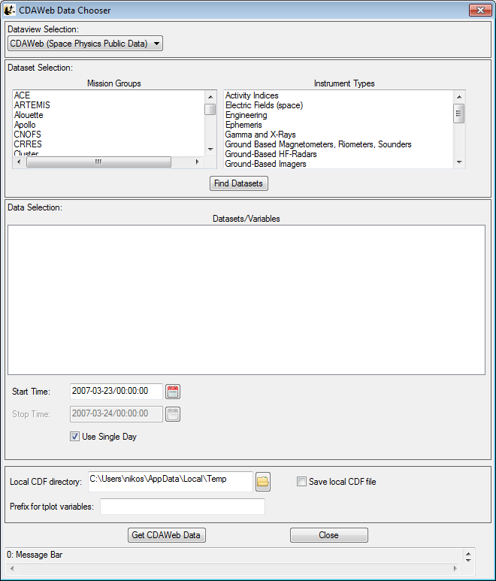"Load Data from CDAWeb" panel

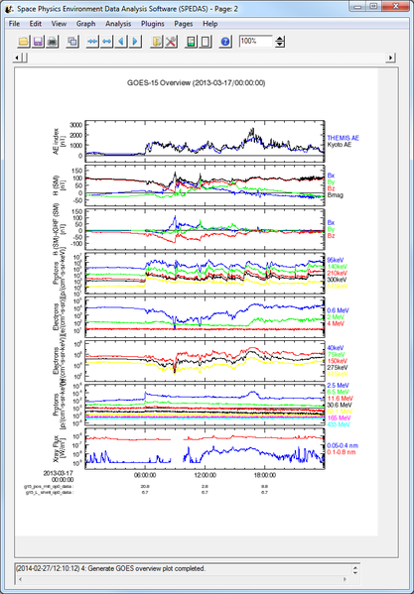GOES-15 summary plot

2. The following enhancements were made to the THEMIS command-line tools:
- L2 SST CDFs are now available, and can be loaded by specifying “level=2” in thm_load_sst
- A new routine “thm_part_products” allows more efficient and flexible generation of moments and spectrograms.
- A new 2-D slice plotting routine “thm_part_slice2d_plot” is available.
- Slices can now be plotted against energy instead of velocity.
- Radial log scaling added for better resolution at low energies
- Linear and radial 1D line plots can be plotted from 2D slices (see thm_crib_part_slice1d).
- Eclipse spin model corrections can now be applied to ESA, SST, and moments data by specifying “use_eclipse_corrections=2” when loading and calibrating Level 1 data.

3. The following enhancements were made to the SPEDAS and THEMIS web sites:
- A graphical data availability timeline is now available for the THEMIS-ARTEMIS, GOES, WIND, and RBSP missions: http://themis.ssl.berkeley.edu/products_availability.shtml
- An interactive graphical instrument configuration timeline for the THEMIS-ARTEMIS instrument suite is now available: http://themis.ssl.berkeley.edu/conf_hist.shtml
- A new site spedas.org has been created to host SPEDAS documentation, an email list, and announcements of interest to developers and users.
- SPEDAS documentation wiki: http://spedas.org/wiki
- SPEDAS news blog: http://spedas.org/blog
- SPEDAS mailing list: http://spedas.org/mailman/listinfo/spedas-list_spedas.org

