STEREO IMPACT FM2 SWEA MCP HV Capacitor Replacement Instructions
The FM1 SWEA MCP HV Filter Cap (C12 on the High Voltage Board) needs to be reworked to provide strain relief .

- Remove the capacitor from the board. Clean remaining epoxy from the land. Be careful not to work/stress the R8 or R9 resistors.

COMPLETED BY ________________________ DATE _________________________________

- Reroute the lead from R9 and from the via that used to meet on top of the capacitor as shown in the attached figure. Adjust the location of the splice away from the location of C12. Keep this end of R9 off the PWB at approximately the same height it originally was. Add a short 26AWG Teflon coated stranded wire from this joint (making it a 3-way lap joint as shown in the figure). This wire will go to C12. Wrap the spice with fine bus wire to provide mechanical integrity before soldering.

COMPLETED BY ________________________ DATE _________________________________

- Silver epoxy a new 1nF 5kV capacitor from CESR flight spares. Use Ablebond 967-1. Locate the capacitor towards the side of the land away from U1 and R9 per the attached figure. Take care not to get epoxy onto the ceramic part of the capacitor.

Epoxy cure information:______________________

COMPLETED BY ________________________ DATE _________________________________

- Silver epoxy the lead from R8 and the stranded wire from the joint in step 2 to the top of the capacitor C12 as shown in the attached figure. Use Ablebond 967-1. Take care not to get epoxy onto the ceramic part of the capacitor.

Epoxy cure information:______________________

COMPLETED BY ________________________ DATE _________________________________

Approved by: _______________________________ Date: ____________________

Old C12 Wiring:
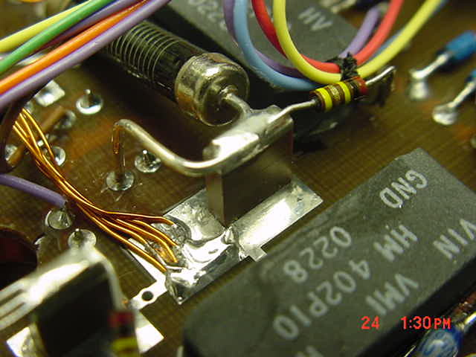

New C12 wiring plan:

